**Atividades 1ª Reunião**

The fundamental issue for micro-wind is the wind resource. It does not matter if a micro-wind turbine is able to rapidly respond to changing wind speeds or work well in turbulent wind if the overall wind resource is poor. [1]

[1] Letcher T. Wind Energy Engineering A Handbook for Onshore and Offshore Wind Turbines, Academic Press, May 2017.

**Definição da estrutura a ser utilizada;**

**Definição do Diametro -**

Struts are used to hold the blades to the main rotor shaft. They need to be strong in order to resist the aerodynamic, gravitational, and centripetal forces exerted on the blades. However, they generally impede power production and decrease the power coefficient through their increased drag.

most of the drag effect is concentrated at the connection to the blade.

There are some advantages in choosing an aerodynamically “smooth” strut design or in covering the strut with a low-drag fairing, and the use of symmetric airfoil sections for fairing the struts is recommended [20], [30]. In one demonstration turbine, the addition of aerodynamic fairings to round pipe struts resulted in a 15% increase in measured performance [15]

It is recommended to minimize the number of struts concomitantly with good structural design, as each strut removed eliminates some parasitic drag on the rotor and ultimately results in a higher power production.

[1] Letcher T. Wind Energy Engineering A Handbook for Onshore and Offshore Wind Turbines, Academic Press, May 2017.

[15] Sutherland HJ, Berg DE, and Ashwill TD. A retrospective of VAWT technology. Sandia Report SAND2012-0304, Sandia National Laboratories; 2012.

[20] Kirke B. Evaluation of self-starting vertical axis wind turbines for stand-alone applications, Ph.D. thesis. Queensland, Australia: Griffith University; 1998.

[30] Kjellin J, Bulow F, Eriksson S, Deglaire P, Leijon M, Bernhoff H. Power coefficient measurement on a 12 kW straight bladed vertical axis wind turbine. Renew Energy 2011;36:30503.

**Definição do tipo de estrutura (hélices);**

Based on the shape of these blades, they generally produce positive torque at every angle when they are operating in their optimal conditions. As a result, lift based VAWTs are generally more efficient than drag-based VAWTs. [1]

Drag-based VAWTs are able to self-start and lift-based VAWTs have difficulty starting by themselves. In addition, symmetric airfoils also suffer from the self-starting problem. [1]

With this in mind, however, the choice of an airfoil is of paramount importance as “the power produced by a [VAWT] at different wind speeds [is] largely determined by its blade airfoil”. [22]

One such design involves the use of cambered airfoils (discussed later). However, even some designs with cambered airfoils still feature dead-band regions, which delay or impede self-starting. [21]

“Cambered fixed pitch blades appear to offer the best combination of acceptable starting torque and peak performance with simplicity and low cost” [20]

Some aspects to consider include the thickness of the blades with respect to structural stiffness (thicker blades being stiffer), ease of construction (manufacture), weight (thinner blades being lighter), etc. [1]

In general, it has been found that higher aspect ratio blades result in better performance, just as with aircraft wings, due to the reduction in reduced drag from tip vortices, (aspect ratios much higher than 7.5 [20]).

Sandia VAWT development, writes: “. *. .the use of 3 blades appears to be optimal . . . adding more blades appears to add significant costs without reducing balance-of-system costs”.* [15] A study comparing 3- and 6-bladed designs numerically, found that the power coefficient was higher for a 3-bladed design. [31]

[1] Letcher T. Wind Energy Engineering A Handbook for Onshore and Offshore Wind Turbines, Academic Press, May 2017.

[15] Sutherland HJ, Berg DE, and Ashwill TD. A retrospective of VAWT technology. Sandia Report SAND2012-0304, Sandia National Laboratories; 2012.

[20] Kirke B. Evaluation of self-starting vertical axis wind turbines for stand-alone applications, Ph.D. thesis. Queensland, Australia: Griffith University; 1998.

[21] Basilevs Y, Korobenko A, Deng, Yan J, Kinzel M, Dabiri JO. Fluid-structure interaction modeling of vertical-axis wind turbines. J Appl Mech 2014;81 081006-1.

[22] Islam M, Fartaj A, Carriveau R. Analysis of the design parameters related to a fixed-pitch straight-bladed vertical axis wind turbine. Wind Eng 2008;32(5):491507.

[31] Hassan S, Ali M, Islam M. The effect of solidity on the performance of H-rotor Darrieus turbine. International Conference on Mechanical Engineering; 2016.

**Tamanho e volume total da estrutura;**

In particular, the larger the turbine diameter, the longer the blade struts must be to support the blades. Thus, a larger diameter turbine is more massive and has a direct effect on the turbine inertia, larger turbine diameter results in a slower angular velocity, slower angular velocity then may require that a gearbox be included in the design to ensure the angular velocity of the generator is sufficiently high for efficient power production.

A smaller turbine diameter leads to higher centripetal forces on the rotor blades. Higher angular velocities also increase the propensity for fatigue failure of the blade struts due to more frequent cyclic loading.

[1] Letcher T. Wind Energy Engineering A Handbook for Onshore and Offshore Wind Turbines, Academic Press, May 2017.

**Resumo;**

* Counter-rotating VAWTs have been found to have substantially increased power density (W m-2) over conventional HAWT wind farms
* VAWTs should be designed to use lift rather than drag as the basis of operation
* VAWTs can have difficulty self-starting, but careful airfoil selection and cambered airfoil profiles can alleviate these difficulties
* The Selig S1210 and DU 06-W-200 airfoil profiles have been shown to self-start and form a currently acceptable starting point for new blade airfoil designs;
* Struts should be shaped to reduce aerodynamic drag
* Lower turbine rotor mass, larger aspect ratio blades (e.g., long “slender” blades), blade-tip devices (e.g., winglets), and 3-bladed rotor designs are preferred.

The VAWT field is relatively nascent compared to HAWTs. As more research is completed and published, some of the design guidance herein may be superseded as the technology improves. The reader is advised to always consider any new research that becomes available.

[1] Letcher T. Wind Energy Engineering A Handbook for Onshore and Offshore Wind Turbines, 2016.

**Viabilidade de energia solar;**

Extremamente viável, tendo como base a eficiência do VAWT para o atual escopo do projeto.

**Media de energia gerada;**

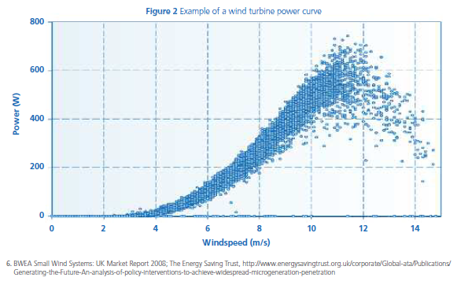

Fonte: [11]

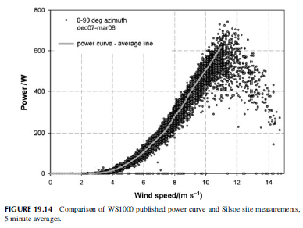

Fonte: [1]

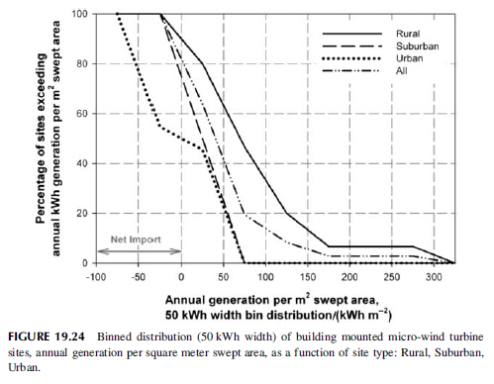

Fonte: [1]

It is that there is simply insufficient wind resource in urban and suburban locations [11]. Deploying micro-wind turbines in these locations will lead to very poor load factors (typically 2%) and in some cases they may even be negative due to the parasitic AC power draw of the inverter.[1]

1.5kW building-mounted turbine located in Scotland was only 7.4 per cent, corresponding to around 975 kWh, or £12710 of electricity generation per annum.[11]

The average monitored load factor was 19 per cent, and the best sites had load factors of 30 per cent or greater. A 6kW turbine with a 30 per cent load factor would be expected to produce approximately 18,000kWh per annum, which equates to £2,340.[11]

[1] Letcher T. Wind Energy Engineering A Handbook for Onshore and Offshore Wind Turbines, Academic Press, May 2017.

[11] Energy Saving Trust (EST). Location, location, location: Domestic small scale wind field trial report; July 2009.

**Induced wind profile from highways**

The induced wind velocity measured at a 1 m height from the highway with a lateral distance of 1 m, 2 m, and 3 m away from the vehicles.

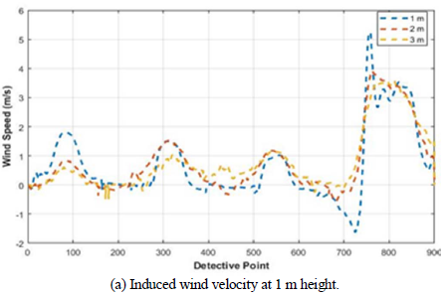

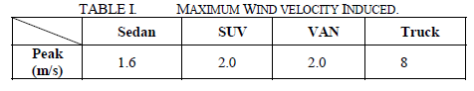

Table I shows the maximum induced wind velocity by different vehicle models.

Sozer Y, Bandarkar A. Energy Harvesting from Moving Vehicles on Highways, University of Akron, September 2019